How to Create Personal Website using Jakyll Bootstrap and Rmarkdown and Github.

A Github Pages template for academic websites. This was forked (then detached) by [Stuart Geiger](https://github.com/staeiou) from the [Minimal Mistakes Jekyll Theme](https://mmistakes.github.io/minimal-mistakes/), which is © 2016 Michael Rose and released under the MIT License. See LICENSE.md.

[GitHub pages](https://pages.github.com/) is a free service in which websites are built and hosted from code and data stored in a GitHub repository, automatically updating when a new commit is made to the respository.

You can fork [this repository](https://github.com/academicpages/academicpages.github.io) right now, modify the configuration and markdown files, add your own PDFs and other content, and have your own site for free, with no ads!

**Getting started**

1. Register a GitHub account if you don’t have one and confirm your e-mail (required!)
2. Fork [this repository](https://github.com/academicpages/academicpages.github.io) by clicking the “fork” button in the top right.

<https://github.com/academicpages/academicpages.github.io>

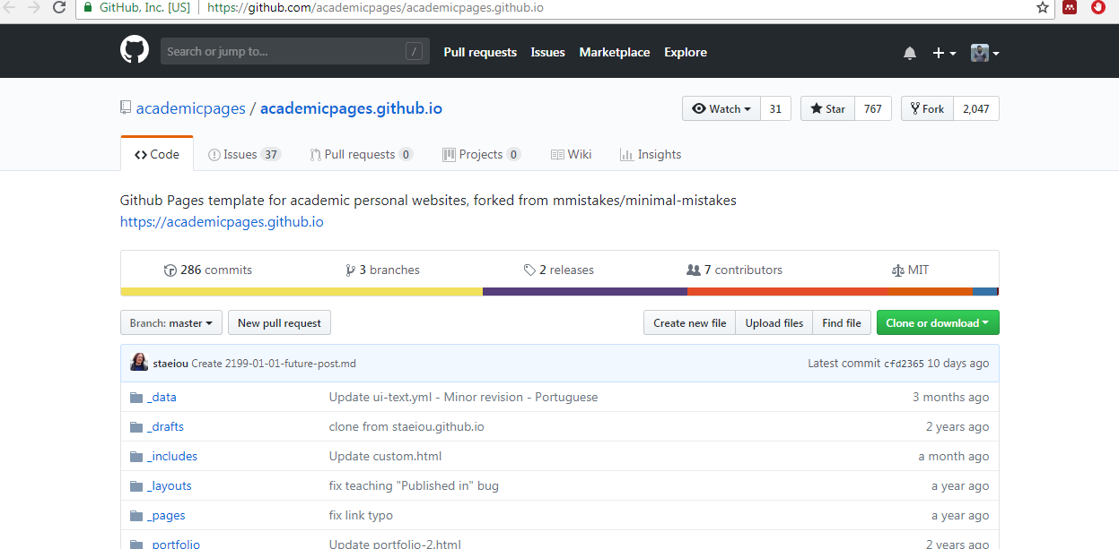

1. Go to the repository’s settings (rightmost item in the tabs that start with “Code”, should be below “Unwatch”). Rename the repository “[your GitHub username].github.io”, which will also be your website’s URL.

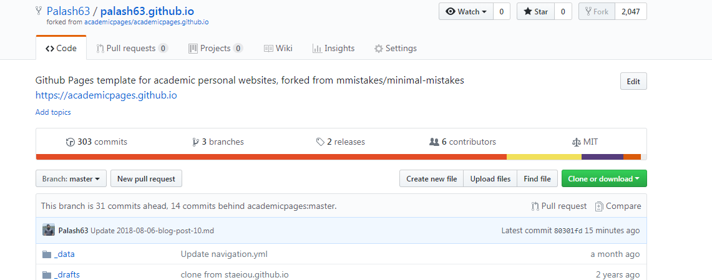

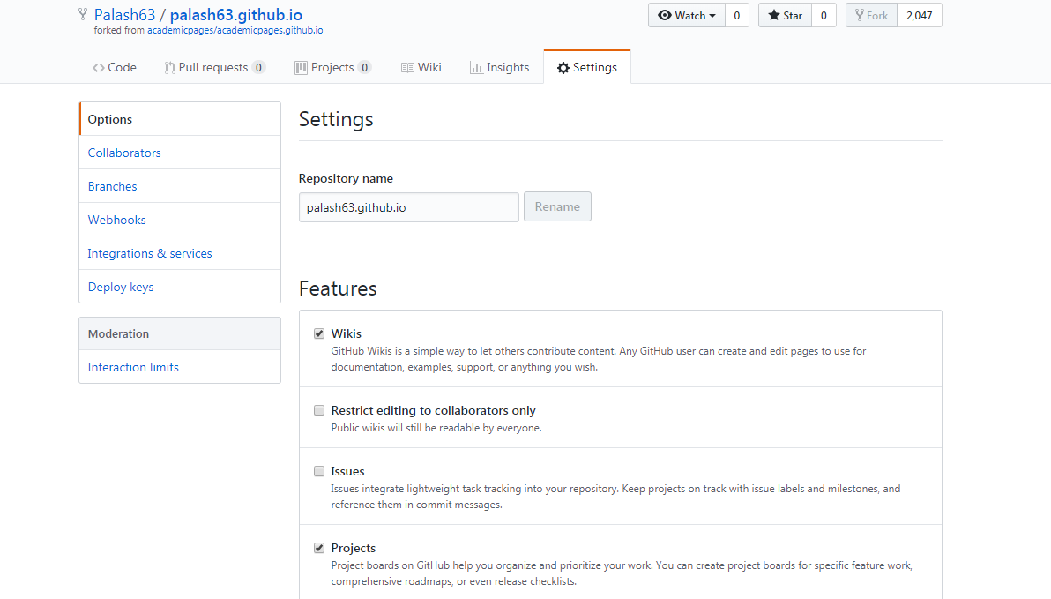

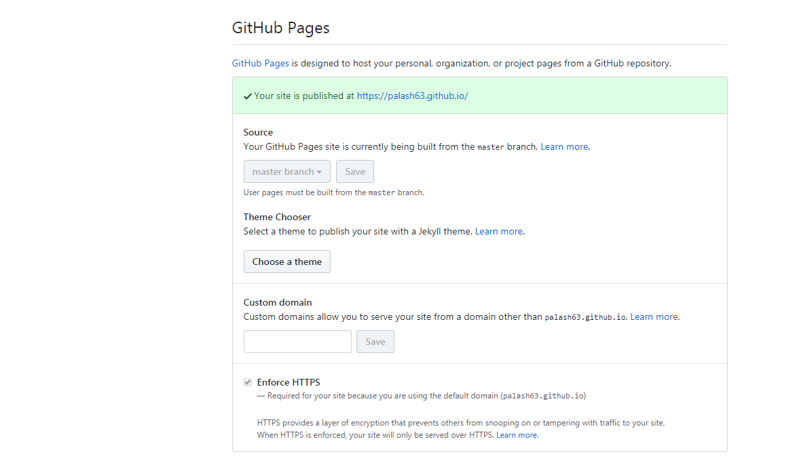

1. Set site-wide configuration and create content & metadata (see below – also see [this set of diffs](http://archive.is/3TPas) showing what files were changed to set up [an example site](https://getorg-testacct.github.io/) for a user with the username “getorg-testacct”)
2. Upload any files (like PDFs, .zip files, etc.) to the files/ directory. They will appear at https://[your GitHub username].github.io/files/example.pdf.
3. Check status by going to the repository settings, in the “GitHub pages” section

## Site-wide configuration

The main configuration file for the site is in the base directory in [_config.yml](https://github.com/academicpages/academicpages.github.io/blob/master/_config.yml), which defines the content in the sidebars and other site-wide features. You will need to replace the default variables with ones about yourself and your site’s github repository. The configuration file for the top menu is in [_data/navigation.yml](https://github.com/academicpages/academicpages.github.io/blob/master/_data/navigation.yml). For example, if you don’t have a portfolio or blog posts, you can remove those items from that navigation.yml file to remove them from the header.

http://archive.is/3TPas

## Create content & metadata

For site content, there is one markdown file for each type of content, which are stored in directories like _publications, _talks, _posts, _teaching, or _pages. For example, each talk is a markdown file in the [_talks directory](https://github.com/academicpages/academicpages.github.io/tree/master/_talks). At the top of each markdown file is structured data in YAML about the talk, which the theme will parse to do lots of cool stuff. The same structured data about a talk is used to generate the list of talks on the [Talks page](https://academicpages.github.io/talks), each [individual page](https://academicpages.github.io/talks/2012-03-01-talk-1) for specific talks, the talks section for the [CV page](https://academicpages.github.io/cv), and the [map of places you’ve given a talk](https://academicpages.github.io/talkmap.html) (if you run this [python file](https://github.com/academicpages/academicpages.github.io/blob/master/talkmap.py) or [Jupyter notebook](https://github.com/academicpages/academicpages.github.io/blob/master/talkmap.ipynb), which creates the HTML for the map based on the contents of the _talks directory).

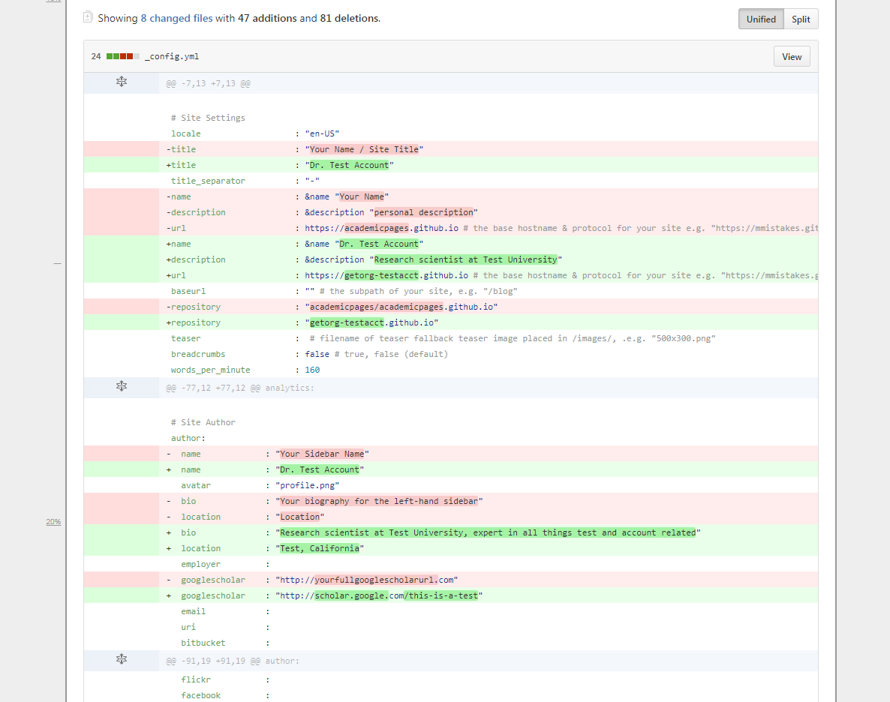

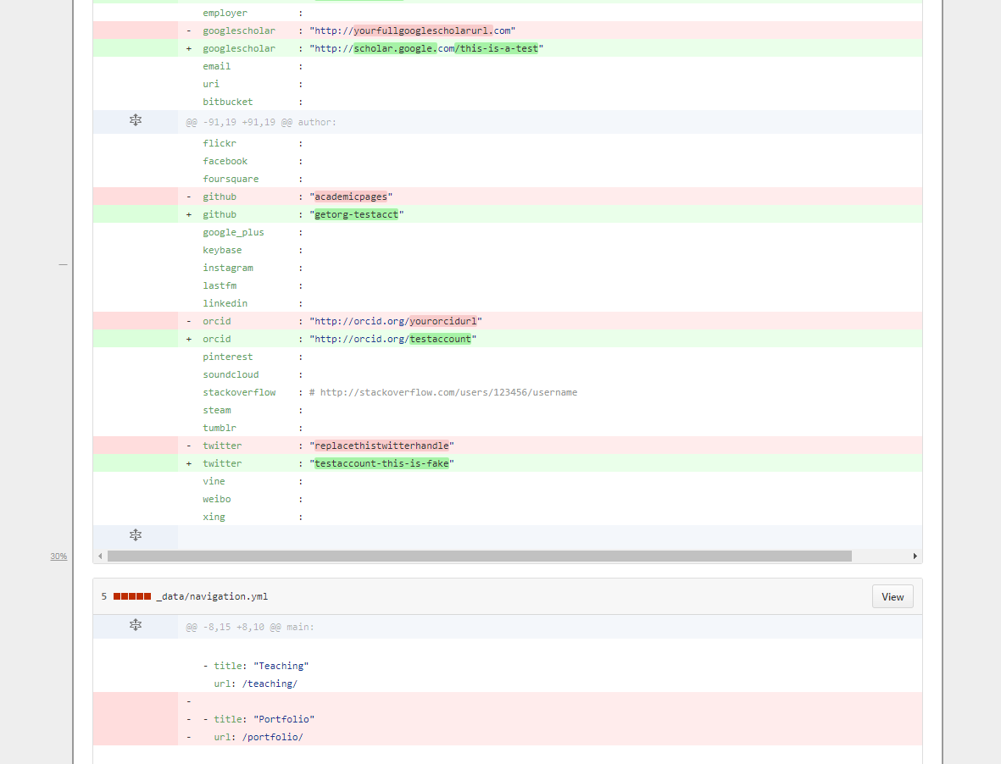

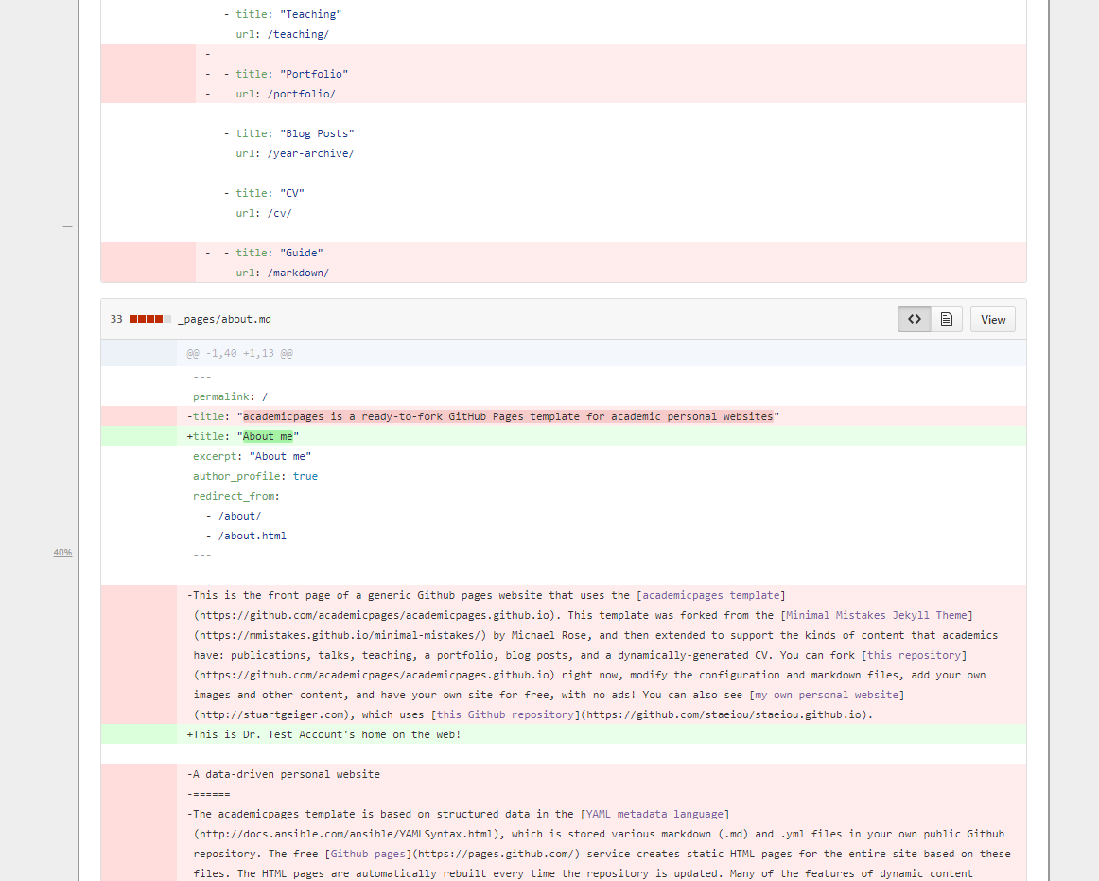

**Markdown generator**

I have also created [a set of Jupyter notebooks](https://github.com/academicpages/academicpages.github.io/tree/master/markdown_generator) that converts a CSV containing structured data about talks or presentations into individual markdown files that will be properly formatted for the academicpages template. The sample CSVs in that directory are the ones I used to create my own personal website at stuartgeiger.com. My usual workflow is that I keep a spreadsheet of my publications and talks, then run the code in these notebooks to generate the markdown files, then commit and push them to the GitHub repository.

## To run locally (not on GitHub Pages, to serve on your own computer)

1. Clone the repository and made updates as detailed above
2. Make sure you have ruby-dev, bundler, and nodejs installed: sudo apt install ruby-dev ruby-bundler nodejs
3. Run bundle clean to clean up the directory (no need to run --force)
4. Run bundle install to install ruby dependencies. If you get errors, delete Gemfile.lock and try again.
5. Run bundle exec jekyll liveserve to generate the HTML and serve it from localhost:4000 the local server will automatically rebuild and refresh the pages on change.

## How to edit your site’s GitHub repository

Many people use a git client to create files on their local computer and then push them to GitHub’s servers. If you are not familiar with git, you can directly edit these configuration and markdown files directly in the github.com interface. Navigate to a file (like [this one](https://github.com/academicpages/academicpages.github.io/blob/master/_talks/2012-03-01-talk-1.md) and click the pencil icon in the top right of the content preview (to the right of the “Raw | Blame | History” buttons). You can delete a file by clicking the trashcan icon to the right of the pencil icon. You can also create new files or upload files by navigating to a directory and clicking the “Create new file” or “Upload files” buttons.

Few Tricks:

Use excerpt before the permalink---look here for more details. So that not all information will show.

[**palash63.github.io**](https://github.com/Palash63/palash63.github.io)/[_posts](https://github.com/Palash63/palash63.github.io/tree/master/_posts)/**2018-08-06-blog-post-10.md**

**Rendering Rmarkdown file into markdown file since github only use markdown file. To create R markdown to markdown use this..**

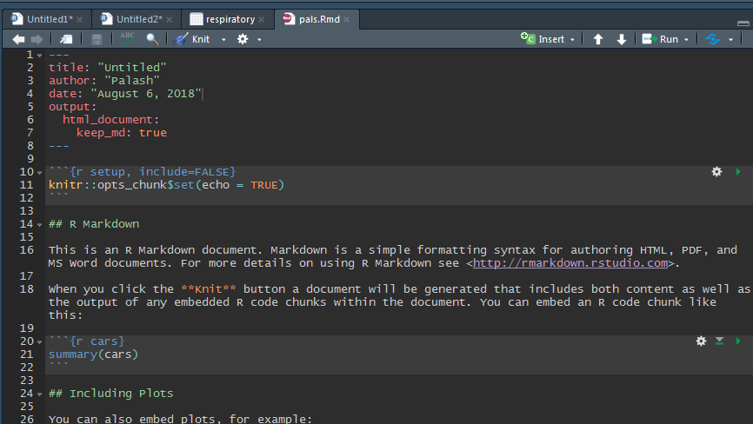

This will create, HTML file, .Rmd file, .Md file and a folder including picture. Need to copy this picture and upload it in the image folder in github reposioty. Then if someone need to include the image in the .md file one need to do <br/><img src='/images/pressure-1.png'>"

That’s it. You are set to go. That’s how you include picture in this repository.

Need to change Publication: Do it in publication folder and need to upload publication in the file section.

